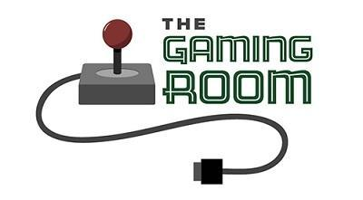

<Name-of-Software-Application>

CS 230 Project Software Design Template
Version 1.0

Table of Contents

CS 230 Project Software Design Template 1
Table of Contents 2
Document Revision History 2
Executive Summary 3
Requirements 3
Design Constraints 3
System Architecture View 3
Domain Model 3
Evaluation 4
Recommendations 5

Document Revision History

Version | Date | Author | Comments
1.0 | 04/17/2026 | Mosunmade Solanke | <Brief description of changes in this revision>

Instructions
Fill in all bracketed information on page one (the cover page), in the Document Revision History table, and below each header. Under each header, remove the bracketed prompt and write your own paragraph response covering the indicated information.

Executive Summary
The Gaming Room seeks to expand its existing game, Draw It or Lose It, into a web-based application that can operate across multiple platforms, including desktop and mobile environments. The primary challenge is designing a scalable, secure, and efficient system that supports real-time multiplayer interactions while maintaining consistent performance across different operating systems.
To address this, a distributed, client-server architecture is recommended, supported by a Linux-based server environment. This approach enables cross-platform compatibility, centralized data management, and scalability through cloud infrastructure. By leveraging web technologies and modern development frameworks, the proposed solution ensures that users can access the game through browsers or mobile devices without requiring platform-specific installations.
This design prioritizes performance, security, and flexibility, allowing The Gaming Room to grow its user base while maintaining a high-quality gaming experience.

Requirements
The business requirements for Draw It or Lose It include expanding the game to reach a broader audience across multiple platforms, supporting multiple concurrent users, and ensuring a smooth and engaging gameplay experience. The system must also maintain high availability and reliability to support real-time interactions between players.
Technical requirements include developing a web-based application that is platform-independent, implementing a scalable server infrastructure, and ensuring secure communication between clients and servers. The system must support user authentication, session management, and persistent data storage for player information and game progress.
Additionally, the application must be designed with performance optimization in mind to handle increasing user demand while minimizing latency and downtime.

Design Constraints
Several design constraints must be considered when developing the application in a web-based distributed environment. One major constraint is cross-platform compatibility, requiring the application to function consistently across different operating systems and devices. This limits the choice of technologies to those that are widely supported, such as web-based frameworks.

Another constraint is network dependency, as the game relies on real-time communication between players. Variations in internet speed and connectivity may impact performance, requiring optimization techniques such as efficient data transfer and latency reduction.

Scalability is also a constraint, as the system must handle fluctuating numbers of users. This necessitates the use of cloud infrastructure and load balancing. Additionally, security constraints require the implementation of encryption and secure authentication methods to protect user data.

These constraints influence development decisions by prioritizing lightweight, efficient, and secure technologies that can operate reliably in a distributed environment.

System Architecture View
While not required for this project, the system architecture for Draw It or Lose It can be understood as a multi-tier architecture consisting of three primary layers: the client layer, application server layer, and data storage layer.

The client layer includes web browsers and mobile devices used by players to access the game. The application server layer handles game logic, user requests, and communication between clients. The data storage layer manages databases that store user information, game states, and scores.

Communication between these layers occurs over a network using standard web protocols such as HTTP/HTTPS. This logical topology ensures separation of concerns, improving scalability, maintainability, and performance.

Domain Model
The UML class diagram for Draw It or Lose It illustrates the relationships between core classes such as Game, Team, Player, and GameService. The Game class represents a single instance of the game and contains attributes related to game state and rules. The Team class groups players together, while the Player class represents individual users participating in the game.

The GameService class acts as a controller, managing the creation and coordination of games, teams, and players. Relationships between these classes demonstrate aggregation and composition, where a Game contains multiple Teams, and each Team consists of multiple Players.

Object-oriented programming principles are evident in the design. Encapsulation is used to protect class data and expose functionality through methods. Inheritance may be used to extend base functionality, while polymorphism allows for flexible interaction between objects. These principles ensure the system is modular, reusable, and easy to maintain.
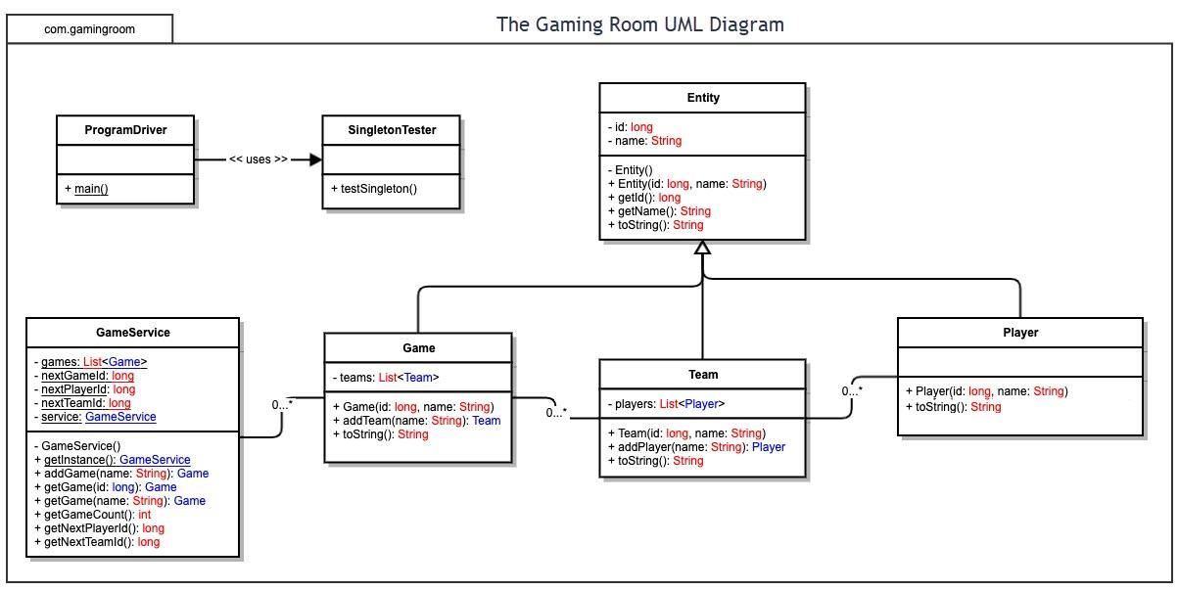

Evaluation

Development Requirements | Mac | Linux | Windows | Mobile Devices
Server Side | Mac operating systems provide a stable and user-friendly development environment but are less commonly used for large-scale server deployments. While they support Unix-based architecture, their higher cost and limited scalability make them less ideal for hosting a web-based application compared to Linux. | Linux is highly suitable for server-side deployment due to its stability, scalability, and cost-effectiveness. It supports a wide range of server technologies and performs well under high workloads. Its open-source nature allows customization, making it the preferred choice for hosting web applications. | Windows Server offers strong support for enterprise applications and integrates well with Microsoft technologies. However, it involves licensing costs and may require more system resources compared to Linux. It is a viable option but less flexible. | Mobile devices are not suitable for server-side hosting due to limited processing power, storage, and reliability. They are designed primarily for client-side interaction rather than backend processing.
Client Side | Supporting Mac clients requires ensuring compatibility with macOS browsers. Development costs are moderate, and expertise in web technologies is sufficient. Testing is necessary to ensure consistent performance across Safari and other browsers. | Linux clients are less common but still important. Supporting them requires ensuring browser compatibility. Development costs are relatively low since web applications are platform-independent. | Windows has the largest user base, making it critical to support. Development considerations include compatibility with multiple browsers such as Chrome, Edge, and Firefox. Costs and effort are moderate. | Mobile support is essential for accessibility. Responsive web design or mobile apps are required. Development may involve additional time and expertise, especially if native apps are considered.
Development Tools | Development tools include Xcode, Visual Studio Code, and web technologies such as HTML, CSS, JavaScript, and frameworks like React. | Linux supports tools such as Eclipse, IntelliJ IDEA, and VS Code. It is widely used for server-side development with languages like Java, Python, and Node.js. | Windows development commonly uses Visual Studio, .NET frameworks, and web development tools. It supports a wide range of programming languages and environments. | Mobile development tools include Android Studio for Android and Xcode for iOS. Cross-platform frameworks like Flutter and React Native can also be used to streamline development.

Recommendations

Analyze the characteristics of and techniques specific to various systems architectures and make a recommendation to The Gaming Room. Specifically, address the following:

- Operating Platform: It is recommended that The Gaming Room use a Linux-based server platform, such as Ubuntu Server, to host Draw It or Lose It. Linux provides a stable, scalable, and cost-effective environment that is widely used for web-based and distributed applications. Its compatibility with cloud services allows the game to expand easily as user demand increases. This platform supports cross-platform access, enabling users on Windows, macOS, and mobile devices to interact with the game through a web browser. Additionally, Linux offers strong performance and reliability, making it well-suited for handling real-time multiplayer gameplay.

- Operating Systems Architectures:The recommended Linux platform uses a monolithic kernel architecture, where core services such as memory management, process management, and device drivers operate within the kernel. This allows for efficient communication between system components and improved overall performance.
Linux also supports multi-user and multitasking capabilities, which are essential for a multiplayer game environment. The system follows a client-server architecture, where the server processes requests and manages game logic while clients interact through user interfaces.
Furthermore, Linux supports containerization technologies such as Docker, which allow the application to be packaged and deployed consistently across different environments. This improves scalability and simplifies maintenance.
- Storage Management: A relational database management system (RDBMS) such as MySQL or PostgreSQL is recommended for managing application data. These systems provide structured storage for user accounts, game sessions, and scores, ensuring data integrity and consistency.
Linux file systems, such as ext4, provide reliable storage with journaling capabilities that help prevent data loss in the event of system failure. For scalability, cloud-based storage solutions can be integrated to handle growing amounts of data and user activity.
This approach ensures efficient data retrieval, reliability, and the ability to scale as the application grows.
- Memory Management: Linux uses advanced memory management techniques, including virtual memory, paging, and demand paging. Virtual memory allows the system to extend physical memory using disk space, ensuring that the application can continue to function even under heavy loads.
Paging divides memory into fixed-size blocks, which improves efficiency and reduces fragmentation. Demand paging ensures that memory is only allocated when needed, optimizing system performance.
These techniques are critical for Draw It or Lose It, as they allow the system to handle multiple concurrent users without performance degradation or system crashes.
- Distributed Systems and Networks: To support communication across multiple platforms, Draw It or Lose It should use a distributed system architecture. This involves multiple servers working together to process requests and manage game data.
A client-server model combined with RESTful APIs or WebSockets allows real-time interaction between players on different devices. Load balancing can be used to distribute traffic evenly across servers, ensuring consistent performance.
Key considerations include:
- Connectivity: Reliable internet access is required for real-time gameplay.
- Fault tolerance: Redundant systems ensure availability during outages.
- Latency: Optimized communication reduces delays between players.
Cloud infrastructure enhances scalability and ensures that the system can handle increases in user demand without service disruption.
- Security: Security is essential for protecting user data and maintaining trust. The recommended platform supports multiple security measures, including:
- Encryption: Use HTTPS with TLS to secure data transmitted between clients and servers.
- Authentication: Implement secure login systems with encrypted passwords and user verification.
- Access Control: Use role-based permissions to restrict access to sensitive data.
- Firewalls: Protect servers from unauthorized access.
- Regular Updates: Apply system patches to address vulnerabilities.
Linux provides strong built-in security features, such as user permission controls and secure configuration options. Combined with best practices in application security, these measures ensure that user information is protected across all platforms.

